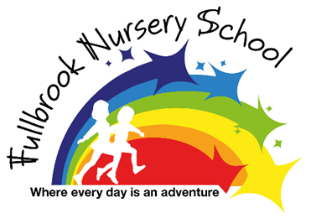Early Reading and Phonological Awareness
At Fullbrook Nursery, we understand and value the importance of children developing the necessary pre-requisite skills that will allow them to become good readers. These pre-requisite skills include developing their listening skills to enable them to discriminate between sounds, keep a beat/rhythm, notice rhyme and alliteration in stories and rhymes and beginning to hear oral blending (letter sounds) in words. We develop these skills through the introduction of our Phonics Friends.
Phonics Friends
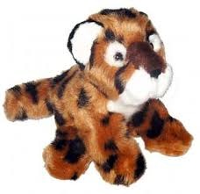
Meet our Phonics Friends. There are six friends and each of them will help children to develop the different pre-requisite skills they need to be a good reader. Each friend will build upon the skills of the previous friend and will provide children with fun and interactive activities that help them explore and develop early reading skills in a developmentally appropriate way.
Listening Leopard
Listening Leopard helps children to develop their listening skills to become aware of sounds in the environment and to increase their vocabulary to talk about those sounds.
Skills children will learn are:
- I can recall a sound I have heard
- I can discriminate between sounds I hear
- I enjoy exploring and making different sounds in the environment using drumsticks and beaters
- I can match a familiar sounds in a lotto game
- I can discriminate between loud/quiet or fast/slow sound
- I can imitate sounds
- I can identify a familiar sound made out of sight
- I can make up sounds for a familiar rhyme
Musical Monkey
Musical Monkey will help children to explore the sounds made by both instruments and their bodies. Children will develop a greater awareness of the differences between these sounds including their rhythm and their pattern and will be able to talk about this. They will also develop a greater understanding of rhythm in stories and songs/rhymes they share.
Skills children will learn:
- I can identify an instrument being played
- I can listen and respond to an instrument being played
- I can talk about the sounds the instruments make using increasing range of vocabulary
- I can remember and repeat a simple rhythm
- I can start and stop playing with a signal
- I can discriminate and reproduce a quiet/loud sound
- I can use sounds imaginatively and describe them.
- I can join in with words and actions to familiar songs and make up some new words for them.
- I can use my body to make sounds and can talk about them.
- I can keep in time with a beat
- I can use a wider range of vocabulary to talk about the sounds I hear.
- I can show an increasing awareness of rhythm in speech as I share books, rhymes and play games.

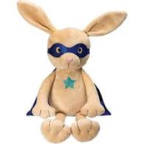
Rhyming Rabbit
Rhyming Rabbit will help children experience rhyme in songs and speech. They will develop an increasing awareness of words that rhyme.

Skills I will learn:
- I can show an increasing awareness of rhyme in speech as I share books and play games.
- I can sing or chant simple rhyming strings with an adult
- I can recognise a rhyming word
- I can complete a sentence using an appropriate rhyming word.
- I can make up my own rhymes
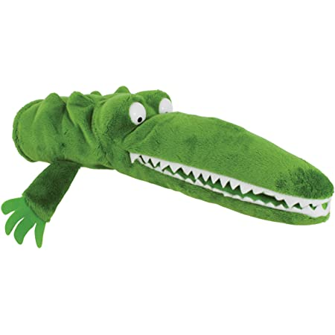
- I can make and talk about a series of words that rhyme.

Alliteration Alligator
Alliteration Alligator will help children to develop an awareness of alliteration by listening to the sounds at the beginning of words and be able to hear the differences between them. They will also explore how letter sounds are articulated clearly.

Skills I will learn:
- I enjoy sharing stories, rhymes and games that help develop my awareness of alliteration.
- I can recall a list of objects beginning with the same sound
- I can match objects to the correct letter sound
- I can say speech sounds correctly.
- I can tell you an increasing range of words that begin with the same letter sound
- I can make up my own alliterations

Blending Bear
Blending Bear will help children to develop their oral blending and segmenting. They will be able to listen to the phonemes in words and remember the order of them.

Skills children will learn:
- I can distinguish between the different vocal sounds
- I can hear oral blending and identify the object/word.
- I can orally segment words into their phonemes.
- I can identify how many phonemes in a word

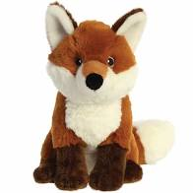
Phonics Fox
Phonics Fox Introduces the children to our phonics scheme Read Write Inc. (RWI). This will help children to learn to say a phoneme and recognise and write the letter that represents it. They will use their blending and segmenting skills to read and write some simple words using the letters they have learned. Children will also learn to read some tricky high frequency words by sight.
Skills children will learn:
- I can say discrete phonemes and recognise and write the letter that represents that phoneme.
- I can find the correct letter in response to a letter sound being spoken
- I can quickly say a letter sound when I see it.
- I can read simple VC and CVC words using the letters sounds I have learned.
- I can read high frequency tricky words by sight.
- I can write some simple VC and CVC words using the letter sounds I have learned.

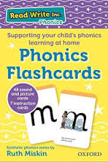
Phonetic Letter Sounds and Writing and Letter Formation.
In nursery we use Read, Write, Inc. to help children learn phonetic letter sounds and understand how we write each letter. The letter formation phrases are as follows:
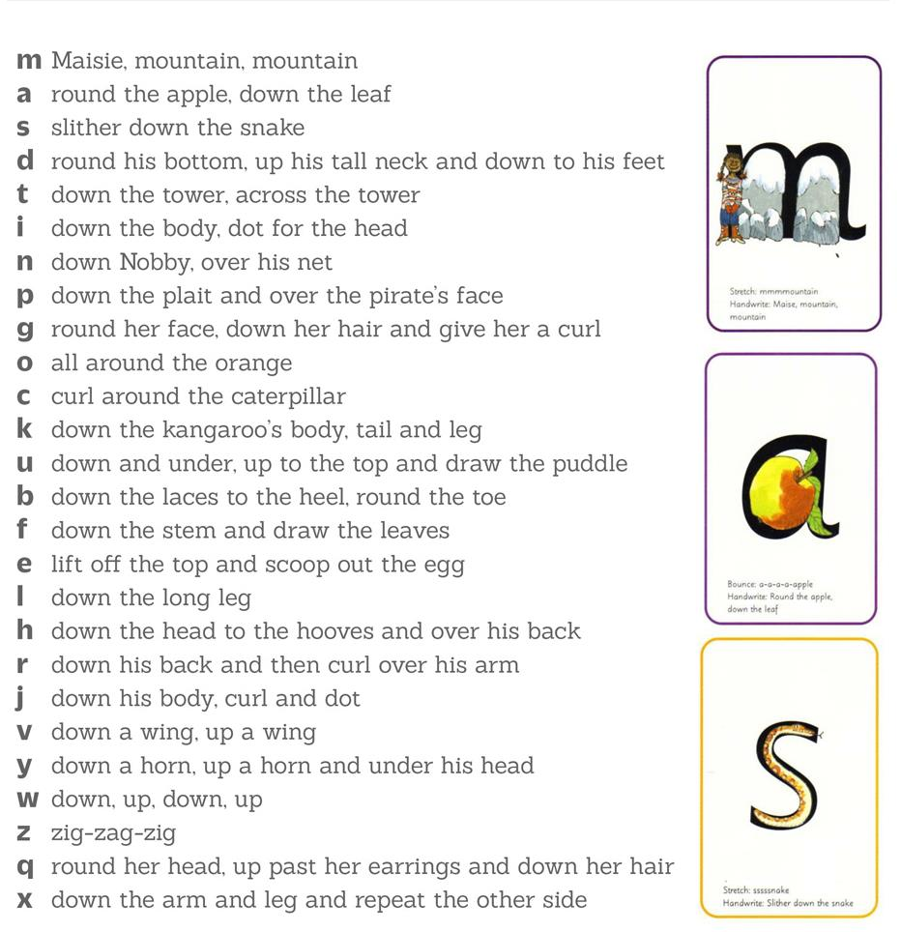
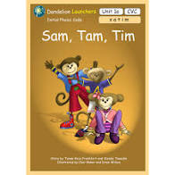
Reading Scheme – Dandelion Launcher
The Dandelion Launcher books are designed to help children read more fluently. In Nursery we will focus upon reading units 1-3 if and when the children are ready to do so and have securely gained the skills developed using our Phonics Friends and RWI. Children will be confidently blending and segmenting words orally and recognise some letter sounds before home reading books are introduced.

