Governance Strategic Policy
Delivering an effective cycle of reporting, robust challenge and accountability.

Associated documents;
Governance Operations Plan (April 23-24), Governance Improvement and Implementation Plan (GIIP April 23-24), School Improvement Plan (Sept 23-24).

Aims of the policy
Enabling effective governance through;
- ensuring clarity of vision, ethos and strategic direction.
- holding leaders to account for the educational performance of the organisation, including its pupils and the performance management of staff.
- overseeing the financial performance of the organisation and making sure its money is well spent.
- ensuring the voices of stakeholders are heard.
This policy is based on six key features of effective governance;
Strategic leadership, accountability, people, structures, compliance and evaluation.
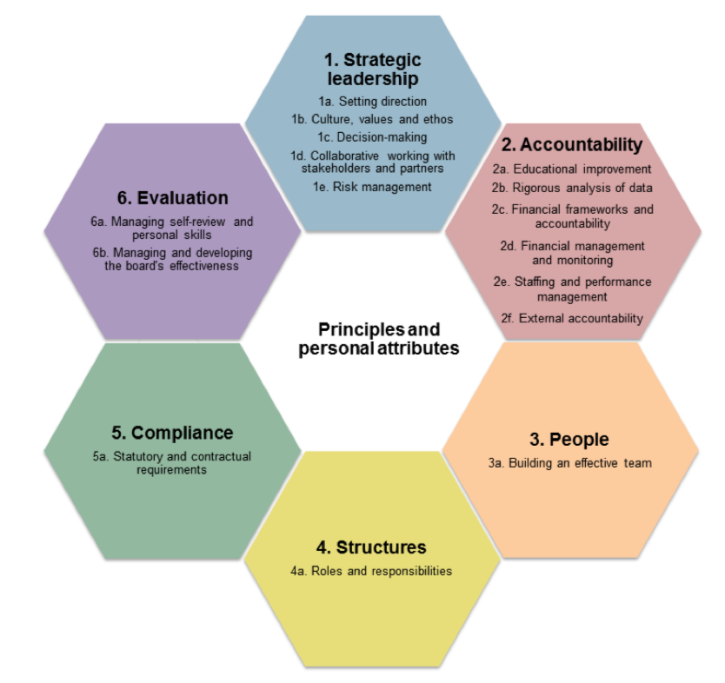
Competency Framework for Governance, DfE 2017.
Strategic Leadership

Our Mission
Our mission, as Fullbrook’s Governing body, is to help transform the lives of the children and families we work with, through high quality education and care, by creating a nursery which feels like home offering an extended and supportive family environment.

Our Governor Values
As a governing body we hold eight core beliefs which provide strong foundations to our work and are based on the Nolan principles of public life. Every governor is committed, confident, curious, creative, courageous, collaborative and seeks clarity through challenge.

Our Vision
Through effective governance Fullbrook Nursery School will continue to be an inclusive centre for early excellence, where…
All Children achieve and reach their full potential as they learn through play, fun and laughter,
Parent partnerships are strengthened as they engage with us to support their child’s learning,
Staff continue to learn, flourish and smile,
We strengthen our community, benefiting our families, as well as others across Walsall

And where we celebrate neurodiversity, individuality and equality.
Governance Strategic Aims
- to set long-term strategic goals, highlighting improvement priorities which are understood by all in the organisation.
- establish and deliver a process to monitor and review progress against agreed strategic goals and to refresh the vision and goals periodically.
- mechanisms for enabling the board to listen, understand and respond to the voices of parents/carers, pupils, staff and local communities.
- determination to initiate and lead strategic change when this is in the best interests of children and the organisation, and to champion the reasons for, and benefits of, change to all stakeholders.
- to set and manage risk appetite and tolerance; ensuring that risks are aligned with strategic priorities and improvement plans and that appropriate intervention strategies are in place and risk management is embedded at every level of governance.
- to ensure the sustainability of the MNS model and make an informed decision on when/ whether to form, join or grow a group of schools which is underpinned by robust due diligence and an awareness of the need to review the effectiveness of governance structures and processes if and when the size, scale and complexity of the organisation changes.
- Through periods of improvement, disruption or expansion, the governing body will create a Governance Improvement and Implementation Plan, to ensure that the ‘process of change’ is managed effectively.

Accountability
The Governing body will ensure accountability is delivered by;
- providing a rigorous analysis of pupil progress, attainment and financial information with comparison against local and national benchmarks and over time.
- Seeking clarity through challenge by asking key questions on pupil progress and attainment including; Which groups of pupils are the highest and lowest performing, and why? What credible plans are in place for addressing underperformance or less than expected progress? How will we know that things are improving?
- having clear processes for overseeing and monitoring school improvement and financial health, providing constructive challenge to executive leaders;
- a transparent system for performance managing the head teacher, which is understood by all in the organisation, linked to defined strategic priorities.
- effective oversight of the performance of all other employees and the framework for their pay and conditions of service.
- a regular cycle of meetings and appropriate processes to support business and financial planning.
- effective controls for managing within available resources and ensuring regularity, propriety and value for money.
People and Structure

The Governing body will ensure that it has the ‘right’ people and an effective structure by;
- ensuring all members understand the purpose of governance (mission, vision and aims), embrace our core values and all have the necessary skills, as outlined in competency framework for governance and professional clerking, to deliver their role effectively.
- including an effective chair and vice-chair with the ability to provide visionary strategic non-executive leadership.
- provide sufficient diversity of perspectives to enable robust decision making,
- are recruited through robust and transparent processes against a clear articulation of required skills, which are set out in a role specification,
- use active succession planning to ensure the board, and the whole organisation, continues to have the people and leadership it needs to remain effective,
- employ a professional clerk, and as necessary a company secretary, to provide expert advice and guidance and to ensure the efficient and compliant operation of the board.
- appropriate board and committee structures that reflect the scale and structure of the organisation and ensure sufficient and robust oversight of key priorities.
- clear separation between strategic non-executive oversight and operational executive leadership, which is supported by positive relationships that encourage a professional culture and ethos across the organisation
- processes for ensuring appropriate communication between all levels and structures of governance and to pupils, parents/carers, staff and communities.
- published details of governance arrangements including the structure and remit of the board and any committees, which are understood at all levels of governance and leadership and are reviewed regularly.
Compliance

The Governing Body will use a range of mechanisms to ensure compliance is robust across finance, health and safety and safeguarding arrangements. This will include;
- To produce a strategic operations plan that ensures compliance is robust and mapped across the year.
- All Governing Body members have regard to Keeping Children Safe in Education (statutory guidance) to ensure that key safeguarding and safer recruitment duties are undertaken effectively.
- The Link Governor for SEND and Safeguarding reports termly to the Board to ensure all it’s members have oversight of the schools plans to ensure that key duties related to inclusion, special education needs and disability (SEND) and safeguarding are undertaken effectively across the organisation.
- Governors have access to independent financial oversight and monitoring of budgets and other mechanisms of compliance monitoring including, verifying independent accountancy reports, annual Schools Financial Value Standards (SFVS) and Information Commissioners Office audit outcomes.
- The Governing Body uses a rage of evidence, made available to them, to monitor and have an oversight of impact provided by targeted funding streams including EHCP funding and EYPP entitlement.
- All governs have an understanding of, and adherence to, responsibilities under the Equalities Act, promoting equality and diversity throughout the organisation including in relation to its own operation.

Evidence to monitor and improve the quality and impact of governance through;
The governing body will seek clarity through challenge by;
- asking the right questions and ensuring they have access to a range of evidence sources that enable them to make robust evidenced based judgements and decisions; Where are we now? Where are we going? How do we get there? What information do we need? How do we know?
- completing annual skills audits undertaken by governors and aligned to the operational strategic plan, to identify skill and knowledge gaps. The Chair will use this information to inform a discussion around recruitment needs, new governor induction and to identify and highlight’s training opportunities.
- every governor is responsible for engaging in regular self-evaluation activities including the Chair’s of Governors annual mentoring review of individuals’ contribution to the board.
- completing biannual governing body self-audit to review strengths and areas for development.
- external reviews of the board effectiveness, to be undertaken when required, particularly at key growth or transition points, including pertinent feedback during Ofsted inspection activities, to gain an independent expert assessment of strengths and areas for development.
- ensuring that documentation accurately captures evidence of the board’s discussions and decisions, as well as the evaluation of its impact and which complies with legal requirements for document retention.
- using sources of evidence that are triangulated in order to ensure that the mechanisms are in place to enable the board to listen, understand and respond from an informed position, from which to be able to hold leaders accountable.

Triangulation of Evidence Sources.
Triangulation refers to collecting evidence from at least three different sources to verify what the board is told by the senior executive leader. The board will aim for a ‘balanced triangulation’; drawing upon at least three pieces of evidence from across external, school led and governor led sources. The breadth and depth of these sources will enable Governors to respond from a robustly informed position that will allow them to test, challenge and determine the strategic journey of the school. Governors will use diagrams below, to ensure that the evidence presented can be triangulated;

Quality of Education and Learning (curriculum, teaching and learning)

School Led
School Policies & Procedures
Curriculum content
School Website
Staff training and CPD
Staff feedback and Reporting.
Head teachers reports to governance.
School improvement tools (ECERS/ITERS/SSTEW)
SIP and SEF
Parent Surveys
Talking to pupils
Staff qualifications and training
Examples of children’s outcomes/achievement
Data (attainment/progress)
External reports from trusted sources (including NASEN, EYs consultants, Ofsted, Quality Mark, LA representatives)
EEF EY evidence store and EY toolkit (research informed evidence).
Evidence
sources to
triangulate
Quality of Education and Learning
Governor Led
Governing board Q&A
Governor school learning walks.
Link Governor visits and reports.
Governor training and CPD

External/Independent

Safeguarding, Vulnerable and Disadvantaged (including SEND and EYPP,)

Safeguarding Policies & Procedures
Curriculum content
School Website
Staff training and CPD
Single Central Record
Staff feedback and reporting (including Designated LAC teacher)
Head teachers reports to governance.
EYPP strategy
SIP and SEF

Parent Surveys / Focus groups
Talking to pupils
Staff qualifications and training
Examples of children’s outcomes/achievement
Vulnerable Group Data (attainment/progress)
External reports from trusted sources (including NASEN, EYs consultants, Ofsted, Quality Mark, LA representatives)
EEF EY evidence store and EY toolkit (research informed evidence).
LA Safeguarding and H&S audit

Evidence
sources to
triangulate
Safeguarding, Vulnerable and Disadvan. pupils
External/Independent
Governor Led

School Led

Governing board Q&A
Governor school learning walks.
Link Governor visits and reports.
Governor training and CPD

Behaviour and Attitudes to Learning
School Policies & Procedures
Curriculum information
School Website
Staff training and CPD
Positive behaviour support plans
Staff feedback and reporting
Head teachers reports to governance, including incidents of behaviour/bullying.
Amounts of authorised/unauthorised/persistent absence.
SIP and SEF

Parent Surveys / Focus groups
Talking to pupils
Data (Wellbeing/involvement scores)
External reports from trusted sources (including NASEN, EYs consultants, Ofsted, Quality Mark, LA representatives)
EEF EY evidence store and EY toolkit (research informed evidence).

Governor Led

School Led
External/Independent
Evidence
sources to
triangulate
Behaviours and Attitudes

Governing board Q&A
Governor school learning walks.
Link Governor visits and reports.
Governor training and CPD

Finances, Staffing and Resources

Governor Led
External/Independent

External reporting from trusted finance sources (including LA Finance, qualified accountancy reports, playground inspection, Fire Risk Management)
EEF EY evidence store and EY toolkit (research informed evidence).
LA H&S audits.
Financial benchmarking data
External Audit tools (SFVS,ICO)

School Policies & Procedures
School Website
Staff surveys
Staff absences/turnover
Head teachers reports to governance.
SIP and SEF
H&S audits

School Led
Evidence
sources to
triangulate
Finances, staffing and resources

Governing board Q&A
Governor school learning walks.
Governor training and CPD

Leadership & Management

Parent Surveys / Focus groups
Talking to pupils
Social/media coverage
Staff qualifications and training (e.g. NPQEL)
External reports from trusted sources (including NASEN, EYs consultants, Ofsted, Quality Mark, LA representatives)
EEF EY evidence store and EY toolkit (research informed evidence).
Governor Led
External/Independent
School Policies & Procedures
Website
Staff Performance Mentoring/coaching
Staff training and CPD
Staff surveys
Head teachers reports to governance.
SIP and SEF

School Led
Evidence
sources to
triangulate
Leadership and Management

Governing board Q&A
Governor school learning walks.
Link Governor visits and reports.
Governor training and CPD
Governance audit tools including Website compliance,
Head teacher performance management

Key Improvement Priorities April 2023-2024

Improvement Priority | Short term Outcome | Long term Outcome
Strategic Leadership
Effective engagement with stakeholders and increased governance visibility. | Increase 2-way mechanisms for engagement with stakeholders;  Newsletter section,  Website,  Celebration/induction events  Email contact | The board will have a range of mechanisms in place to engage meaningfully with all parents/carers, community and other stakeholders. Parents and carers are seen to be using these mechanisms to put forward their views.
To produce supporting documentation for governance improvement, to include;  - Governance Strategy Policy,  - Governance improvement and Implementation Plan (GIIP). | The governing body will create;  - a Governance Strategy Policy, outlining the boards, vision, mission, aims, values and strategy to governance.  - a Governance Improvement and Implementation Plan to ensure that the ‘process of change’ is managed effectively. | Enabling effective governance through;  - ensuring clarity of vision, ethos and strategic direction.  - holding leaders to account for the educational performance of the school.  - overseeing the financial performance of the school and making sure its money is well spent.  - ensuring the voices of stakeholders are heard.
Develop Link governance roles for curriculum and PSED (Behaviour/Attitudes) | To review governor skills audits  To recruit or strengthen existing governor knowledge regarding the quality of EY education.  Review governance constitution, structure and committees.  Identify and publish new Link governor roles.  New link governor visits and reports available to FGB. | The board will have additional sources of evidence from which to draw conclusions and make judgements against regarding the quality of education and learning and Behaviour and Attitudes.
People & Structure
Ensure that governance knowledge and skills are deepened around curriculum and the quality of education. | Review Structure and Instrument of governance.  Review Governor induction  Develop a process of performance review and mentoring  Develop personal Knowledge and Skills development plan, which outline govern growth each annual cycle. | The boards is a tightly focused, no larger than it needs to be , and has the necessary skills to carry out it functions effectively, with everyone actively contributing relevant skills and experience.  The board has committee structures that reflect the scale and structure of the organisation and ensure sufficient and robust oversight of key priorities.
That there are a range of mechanisms in place to support self-review of individual governor performance and the board as a whole. | To develop a bank of resourced to support self-reflection and review to include;  - Individual performance review  - Personal skills and knowledge development plans  - Governing body self-audit,  - External sources of review identified when appropriate on the operations plan and GIIP | Every governor is responsible for engaging in regular self-evaluation activities including the Chair’s of Governors annual mentoring review of individuals’ contribution to the board.  Range of evidence sources which show self-refection and improvement including a biannual governing body self-audit to review of strengths and areas for development
Compliance
To develop a Governance Operation Plan | To produce a strategic operations plan that ensures compliance activities are robust and mapped across the year to include;  - Policy ratification,  - Website compliance  - Link govern visits and reports  - External reporting  - Financial compliance activities | The Governing body is able to evidence compliance and the robust approach taken to assuring its work.  Website maintains its compliance across the academic year (DfE School information Regulations  advice document on statutory policies for schools).
For the clerk to support the efficient and complaint delivery of draft minutes to the governing body, to enable them to provide accurate, timely and informed actions from meetings. | To ensure that draft minutes of meetings are received by governors within two weeks of the meeting date. | To use a professional clerk, , to provide expert advice and guidance and to ensure the efficient and compliant operation of the board.
For FGB minutes to evidence the all Governors have read and understood the most up to date version of Keeping Children Safe in Education in its entirety. | All governors to be provided with the link to access the most up to date version of KCSIE each Aug/September  For the governance operations plan to identify when governors should read the KCSIE document by and when this task will be an agenda item for discussion. | All Governing Body members have regard to Keeping Children Safe in Education (statutory guidance) to ensure that key safeguarding and safer recruitment duties are undertaken effectively.

Reference Materials
Governance handbook (DfE, 2020)
A Competency framework for Governance (DfE 2017)
Being Strategic; A guide for governing boards and school leaders (NGA, 2020)

