Fullbrook Maintained Nursery School

Governance Improvement & Implementation Plan

April 2023- April 2024 (GIIP)

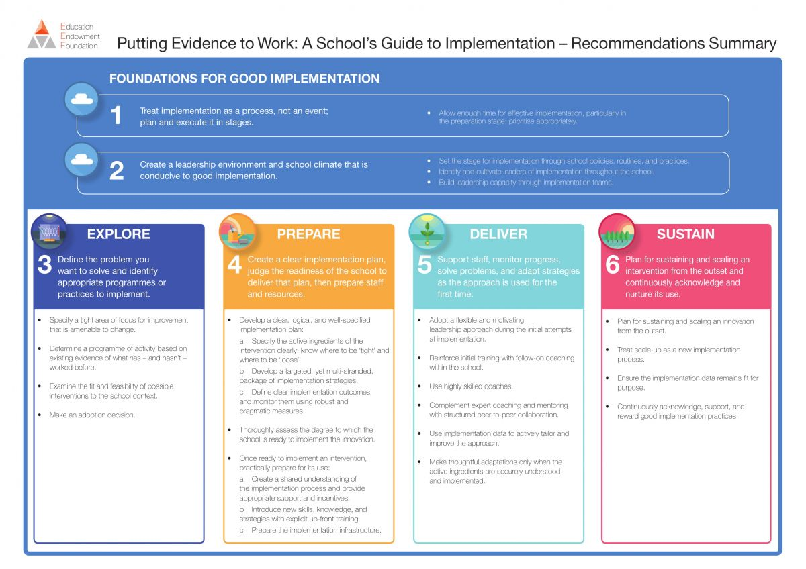
Our intent for Governance improvement is;
- Non-executive Leadership has established a culture that is conductive to change and self-improvement.
- To continue to focus on staff, child and family wellbeing as a priority.
- Decisions are informed by research and evidence-based practice and identified as meeting the needs of our children and community.
- Sharper focus and clarity on the steps needed to drive aspirational and manageable improvements.
- Sustainable improvements are implemented in a logical and sequential order on a journey towards long term goals.
- Annual improvement plans work in sequence to support the consistent ethos and vision of governance and the school.

school context
Key Ofsted actions from last report | To be completed during GIIP review March 2024
Improvement Priorities (including Ofsted feedback Feb 2023) | “Governors keep a careful watch on financial matters, safeguarding and staff well-being. However, some of their other checks on the school’s work are not thorough enough”.  “Governors’ checks on the school’s work are not thorough enough. This means that they do not know enough about how well it is doing. Governors should review their procedures to ensure a more rigorous oversight”.
Key outcomes by April 2024 | - Increase effective engagement with stakeholders and governor’s visibility in school activities.  - To produce supporting documentation for governance improvement, to include;  - Governance Strategy Policy, outlining the boards, vision, mission, aims, values, strategy to governance and triangulation of evidence sources.  - Governance operations plan to include an accurate EYFS Maintained School list of policies for review & ratification.  - Develop Link governors’ roles for curriculum and PSED (Behaviour/Attitudes)  - Governing body’s knowledge and skills are deepened around curriculum and the quality of education.  - There are a range of mechanisms in place to support self-review, including individual governor performance and the board as a whole.  - For the clerk to support the efficient and complaint delivery of draft minutes to the governing body, to enable them to provide accurate, timely and informed actions from meetings  - For FGB minutes to evidence that Governors have read and understand the most up to date version of Keeping Children Safe in Education in its entirety.
Key performance indicators for the next 3 years | - The board will have a range of mechanisms in place to engage meaningfully and increase visibility with all parents/carers, community and other stakeholders. Parents and carers are seen to be using these mechanisms to put forward their views.  - Clear strategic direction for governance, understood across the school by all stakeholders, so that there is clarity of vision, ethos and strategic direction; leaders are held to account for the educational performance of the school and there is clarity in oversight of the school’s financial performance.  - The board will have additional sources of evidence from which to draw conclusions and make judgements against regarding the quality of education and learning and behaviour and attitudes.  - The boards is a tightly focused, no larger than it needs to be , and has the necessary skills to carry out it functions effectively, with everyone actively contributing relevant skills and experience  - Every governor engages in regular self-evaluation activities and there is a range of evidence sources available to demonstrate this including governing body self-audit and an external governance review.  - The Governing body is able to evidence compliance and the robust approach taken to assuring its work through an annual operations plan.  - Governors pedagogical understanding of practices continues to strengthen, this evident in link governor reports and challenge questions.

OBJECTIVES FOR 2023/24
Strengths, issues, risks and opportunities (taking stock -working party summary March 2023). | Strengths:  - Consistency and long-term commitment of the governing body.  - EYs experience and knowledge of the chair.  - Open and honest relationship with leadership team.  - Personal and professional attributes of Governing body members.  Opportunities  - Increase opportunities for engagement and visibility with parents, staff and children. .  Threats/Risks  - Overcome challenges of recruiting a parent governor  - Challenge of recruiting an additional co-opted governor with experience in EYs.
Objective 1  Strategic Leadership | To strengthen governance strategy and mechanisms to enable robust oversight.
Objective 2  People/Structure | Ensure that governance knowledge and skills are deepened around curriculum and the quality of education.
Objective 3  Compliance | To produce a strategic operations plan that ensures compliance activities are robust and mapped across the year.
Objective 4  Evaluation / Self-reflection | There are now a range of mechanisms in place to support self-review of individual governor performance and the board as a whole

Strategic Leadership
Objective 1: To strengthen governance strategy and mechanisms to enable robust oversight.
ACTION | TIMESCALE | PERSON RESPONSIBLE | MONITORING (WHO & HOW OFTEN) | SUCCESS CRITERI
Increase 2-way mechanisms for engagement with stakeholders;  - Newsletter section termly,  - Website strategy information  - Website personal introduction from governors  - Attendance at Celebration/induction events  - Direct email contact governers@full.. (added to website) | Termly  Oct  Oct  July  Sep | Gov  CD  CD  Gov  SL | AF termly  AF annually  AF annually  AF termly  AF- | The board will have a range of mechanisms in place to engage meaningfully with all parents/carers, community and other stakeholders. Parents and carers are seen to be using these mechanisms to put forward their views.
The governing body will create;  - a Governance Strategy Policy, outlining the boards, vision, mission, aims, values and strategic governance aims | Sept | GR | AF | Enabling effective governance through;  - ensuring clarity of vision, ethos and strategic direction.  - holding leaders to account for the educational performance of the school.  - overseeing the financial performance of the school and making sure its money is well spent.  - ensuring the voices of stakeholders are heard.
To develop a triangulation method of selecting a range of evidence sources in order to listen, understand and respond from an informed position.  To be adopted within minuting format. | Sept  Oct | AF  GR | GR  AF | The board will have additional sources of evidence from which to draw conclusions and make robust judgements against regarding the quality of education and learning and Behaviour and Attitudes.

People/ Structure
OBJECTIVE 2: Ensure that governance knowledge and skills are deepened around curriculum and the quality of education.
ACTION | TIMESCALE | PERSON RESPONSIBLE | MONITORING (WHO/ HOW OFTEN) | SUCCESS CRITERIA
Review the instrument of governance constitution, structure, committees and skills audits  Plan to recruit to fill any gaps identified. | Oct | Clerk  AF | GR  Clerk | The board will have additional sources of evidence from which to draw conclusions and make robust judgements against regarding the quality of education and learning and Behaviour and Attitudes.
Strengthen existing governor knowledge regarding the quality of EY education  - External reports  - Training CPD  Joint learning walks | Spring term  Termly | AF | GR
Identify and publish new Link governor roles.  New link governor visits and feedback available to FGB. | Oct  Termly | CD  Govs | AF  GR
Review new governor induction process and induction handbook;  Identify what is best practice  implement improvements | Oct | AF | GR | The boards is a tightly focused, no larger than it needs to be , and has the necessary skills to carry out it functions effectively, with everyone actively contributing relevant skills and experience.  The board has committee structures that reflect the scale and structure of the organisation and ensure sufficient and robust oversight of key priorities
Develop a process of performance review and mentoring;  Chair facilitates annual personal reviews (to include attendance and participatory levels)  Coaching/mentoring when needed | Spring  Summer | GR  GR | AF  AF
From reviews develop individual Knowledge and Skills development plans, which outline governor competency growth each annual cycle. | Summer | GR | AF

Compliance
OBJECTIVE 3: To produce a strategic operations plan that ensures compliance activities are robust and mapped across the year.
ACTION | TIMESCALE | PERSON RESPONSIBLE | MONITORING (WHO & HOW OFTEN) | SUCCESS CRITERIA
To produce a Strategic Operations Plan, that ensures compliance activities are robust and mapped across the year to include;  - Policy ratification,  - Website compliance  - Link govern visits and reports  - External reporting  - Financial compliance activities | Spet | AF/Clerk | GR termly | The Governing body is able to evidence compliance and the robust approach taken to assuring its work.  Website maintains its compliance across the academic year (DfE School information Regulations  advice document on statutory policies for schools).
To ensure that draft minutes of meetings are received by governors within two weeks of the meeting date. | Termly | Clerk | GR | To use a professional clerk, , to provide expert advice and guidance and to ensure the efficient and compliant operation of the board.
All governors to be provided with the link to access the most up to date version of KCSIE each Aug/September  For the governance operations plan to identify when governors should read the KCSIE document by and when this task will be an agenda item for discussion. | Sept  Oct | FGB | GR/Clerk | All Governing Body members have regard to Keeping Children Safe in Education (statutory guidance) to ensure that key safeguarding and safer recruitment duties are undertaken effectively.

Self-reflection and Evaluation.
OBJECTIVE 4: There are now a range of mechanisms in place to support self-review of individual governor performance and the board as a whole
ACTION | TIMESCALE | PERSON RESPONSIBLE | MONITORING (WHO & HOW OFTEN) | SUCCESS CRITERIA
To develop a bank of resourced to support self-reflection and review to include;  - Individual performance reviews  - Personal skills and knowledge development plans  - Governing body self-audit, | Spring | AF/GR | Clerk | Every governor is responsible for engaging in regular self-evaluation activities including the Chair’s of Governors annual mentoring review of individuals’ contribution to the board.  Range of evidence sources which show self-refection and improvement including a biannual governing body self-audit to review of strengths and areas for development
To use an external review to identify progress against GIIP 23/24 and recommend areas for continued improvement for GIIP 24/25. | Summer | GR | AF | External review report to evidence progress against GIIP target 23/24 and outline recommended targets for GIIP 24/25.

