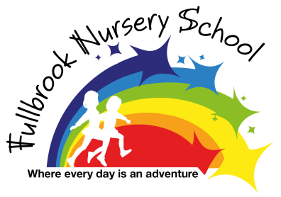

Policy of Curriculum Intent, Implementation and Impact

Cross Policy Links –Staff Code of Conduct, SENDI policy, Assessment policy.
Cited also in – Staff Hand Book, Staff Capability policy, Student Induction Pack, SENDi Information Report, Parent Induction Pack.
Fullbrook Nursery School follows the statutory framework for the revised Early Years Foundation Stage, April 2017.This document covers children from birth to five years, however, we consider the individual needs, starting points, learning styles and interests of the children when planning our curriculum. In addition to the EYFS guidance a wider body of research has been used to inform the creation of our curriculum.
Overall Intention
Is that on exit from nursery call children will have developed;
- Three core characteristics of effective learning these are curiosity, perseverance and resilience.
- Independence to select and use tools and resources for self-motivated purposes.
- Oracy skills to hold conversations, ask questions and tell a short story.
- Prerequisite skills for reading, writing and maths.
- Environmental, societal and economic knowledge to begin their journey to becoming sustainable citizens.

Curriculum Intent
Beginning with each child’s unique developmental starting points, supported through positive and safe relationships, adults will build on children’s existing schemes (prior skills) and schemas (prior knowledge) to secure new knowledge and skills.

Intentional home & school learning environment
Unique, healthy & happy child
Positive, safe & tuned in relationships

Our intention is to teach a broad knowledge based curriculum and support the development of early reading and writing skills and foster a love for Literacy
Reading Diet Intentions
Dialogic Group Reading
- CROWD or CREEER technique used daily to broaden children’s knowledge and vocabulary through engaging in with stories.
Phonetical Awareness
- Daily adult led Letters & Sounds targeted group
- Opportunities to practice and reinforce through play
Speaking & Listening
- Daily Wellcomm adult led targeted group
- Opportunities to practice and reinforce communication through play and routine
Reading Environment
- Print rich – opportunities to raise awareness of print in different contexts, labels, food packaging, instructions, Makaton signs, calendars, days of weeks, logos etc
- Personal marks – Self-register names,
Reading Ready Parents
- Half termly story cafes
- 1000 stories shared at home - workshop and daily shared reading in the home
Celebrating Reading
- 1000 stories shared reward assembly.
- Opportunities to hear stories during child led sessions

Writing Diet Intentions
Scribing
- Opportunities through play for adults to scribe words into writing
- Scribing their stories – Helicopter oral story telling and scribing session
Mark Making
- Weekly Draw & Talk session
- Opportunities throughout the continuous provision and weekly invitation to play.
Fine and Gross Motor Development
- Opportunities throughout the continuous provision and weekly invitation to play
Writing Rich Environment
- Opportunities to see writing modelled and display
Writing Ready Parents
- Workshops and Marvellous Me suggested activities,
Celebrating Writing
- Family group - Look What I’m Taking Home chatter

Curriculum Implementation
Curriculum plans outline the sequential skills and knowledge that will be taught each term or as children reach developmentally appropriate milestones. Curriculum plans inform the teaching of prerequisite skills in reading, writing and maths, Health & Wellbeing (Safeguarding) and our cultural curriculum focused on Sustainable Citizenship (see Appendix 1). A board and balanced curriculum has been designed which focuses on core sequential skills that underpin the development of the whole child and supports them in children GLD at the end of Reception. These key skills are repeated and rehearsed throughout a broad knowledge based curriculum.
Unique, Healthy & Happy Child
Baseline observations and assessments inform the starting points for each child and the curriculum is designed to support children through the sequential ages and stages of EYFS.
In order to learn new knowledge and skills a priority is placed on children’s wellbeing and involvement levels (Ferre Leuven) our Key Worker system is designed to build secure attachments, address wellbeing needs and scaffold involvement.
Explicitly teaching children about feelings and emotions is implemented through “Every Emotion Matters’, whereby adults look for signals regarding children’s emotions and explicitly draw attention to them. Environmental reminders support all adults in ceasing opportunities to supporting children to recognise, understand and verbalise their emotions. These conversations will support children to develop the skills needed to self-regulate their behaviour and have stronger emotional resilience.
Ensuring children’s health needs are meet and supported is a theme that runs throughout our implementation, beginning with our Two-Year-Old Check. In order to children to learn their basic needs of sleep, diet, shelter, health need to be met. In order to support this, we work in partnership with other agencies to offer the ‘right support at the right time’. In particular we support good bend time routines, healthy diets and Oral hygiene (Health and Wellbeing Curriculum Thread).
Beginning with Schemes (prior skills) and Schemas (prior knowledge)
Children schemes and schemas form the basis of our observations and offer practitioners an insight into children’s prior knowledge and skills. Through skilful adult interaction this prior learning is then used to acquire new knowledge and skills that have been identified as ‘missing’. Examples of these ‘learning journeys’ are recorded through observations termly for each child.
Positive, Safe & Tuned in relationships
Adults are central to enabling children’s learning; having positive, safe and ‘tuned in’ relationships is crucial.
Our positive behaviour and positive handling policies outline how these relationships are supported within school.
Our PEGS (Parent Engagement Guide graded gradual grantee goal generation geared Strategy) outlines how our universal, targeted and bespoke support is implemented.
Our Keeping children Healthy and Safe curriculum plan outlines the topics that are addressed in order to support children and parents in safeguarding themselves and their children against harm in an age appropriate way focusing on the most prevalent themes.
In line with safeguarding arrangement, and in order to implement the right support at the right time’ other agencies may also be involved in support positive and safe relationship.
Intentional teaching of oracy skills
Being a Language Excellence School we hold three key principles in language development. All adults are expected to be;
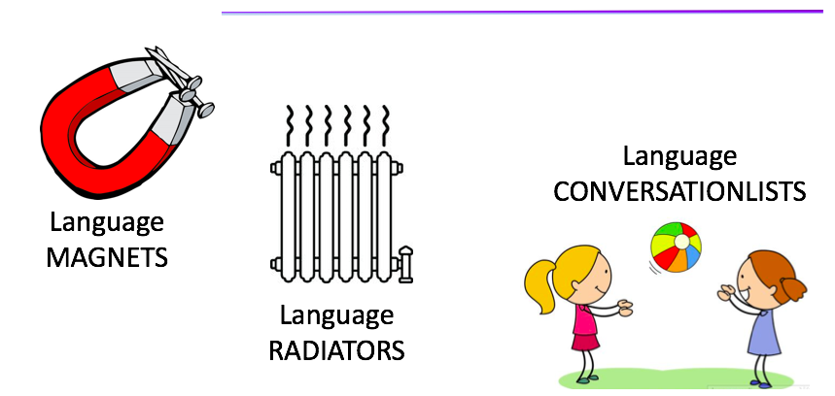
This consistent approach ensures that all adults;
- Attract language - through high expectations of spoken communication and conductive body language.
- Radiate aspirational vocabulary and model good spoken English.
- Engage in frequent, meaningful turn taking conversations with children.
Key vocabulary is taught each week linked to the headline story (knowledge curriculum) and maths focus. Practitioners will explicitly teach these words in many different contexts and support parents to do the same.
Every 10 weeks, children’s language skills are assessed (Wellcomm Screening Tool), this information is then used to inform planning for interventions (1:1, small group, Key worker play partnering). Children then receive the sequential support they need in order to develop their understanding and use of language.
Intentional Interactions
Every interaction between an adult and child provides a learning opportunity, in school, this is implemented by our ShREC approach and is expected to be consistent across all adults. Environmental reminders support adults in using a range of sustained shared thinking strategies to ensure that learning happens in every interaction.

All adults have high expectations of children’s oracy skills and model aspirational vocabulary. Our routine is balanced to allow for 80% of child-initiated learning so that practitioners are able to facilitate and model language within the most meaningful contexts to children.
All interactions are expected to encourage children to risk take, persevere and be resilient; characteristics that enable children to be independent and effective learners. Practitioners implement their knowledge of when they are interacting or interfering and ensure that children are provided with the invaluable experiences of managing risks, preserving to success and developing resilience to try again after failure.

Dialogic Reading
Through daily dialogic reading, the adult supports the child’s oracy development, executive function skills and meta-cognition skills. The adult becomes the listener, the questioner and the audience for the child.
The CROWD prompts used are:

Completion prompts whereby children finish repeated phrases.
Recall prompts for children to remember the story sequence and events.
Open ended prompts asking genuine questions on children’s thoughts, beliefs
and motivations.
What, where, when and who prompts to discuss story events and characters
Distancing prompt to relate the story to their own life experiences.

For our younger children, we use CREER prompts, these help the adult model thinking and oracy skills for children:

Comment on events, characters and pictures.
Remind prompts for children to remember the story sequence and events.
Expand on children thinking
Extend children’s words/phrases
Explaining what is happening in the pictures
Repeating back what children have said in slightly different ways that supports
their understanding.
Our weekly headlining story also has a vocabulary focus; our wow word of the week and a consistent definition is referred to by adults in meaningful play contexts, supporting children to become more word aware. This is particularly effective for children who have limited listening and attention and English as an additional language. Half termly story cafes provide regular opportunities to model the dialogic technique to parents.
Through dialogic reading, the children hear the same story 5 times during the week and children learn;
- Breadth of story vocabulary and phrases,
- Securely recall a story sequence, key events and characters.
- Relate and extend their knowledge through the experiences/vocabulary within books,
- Respond appropriately to variations in questioning and begin to ask their own.

Through a love for stories
Children’s literature is core to our curriculum implementation. Stories are skilfully chosen to match children’s existing schemes and schemas and provide ‘hook’s for new learning outlined in our curriculum plans (Healthy & Wellbeing, Sustainable Citizenship , Literacy and Maths). Each week, children experience a headline story and have opportunities to hear other stories linked to their interest at opportunities throughout the routine. Adults read with enthusiasm, intonation and expression.
Using the Helicopter Stories approach, children develop the skills to orally tell their own stories and take part in re-enacting the stories of others. This is a key pre-request skill for writing.
Our 1000 stores shared at home project supports high quality interactions around story telling in the home. Consistent in approach, it provides a focus on learning new vocabulary and crucially talking about the stories shared.

Sustainable Citizenship Curriculum Plan – broad knowledge base
Our knowledge curriculum plan has been created around three key sustainable citizenship themes of environmental, societal and economic. The knowledge content supports children’s understanding of;
- Place, home and family
- Animals, nature & environments
- Community jobs and roles
The knowledge curriculum plan is designed to begin with our two-year olds and then spiral outwards so that children revisit knowledge and sequentially deepen it. It is intended that children journey from ‘emergent thinkers’ (surface knowledge and initial skills) towards ‘relational thinkers’ (deeper knowledge, connective thinking and transitional skills). It has been designed as a pre-sequence to the National Curriculum.
Within the knowledge curriculum, children’s cultural capital forms the basis on to which new knowledge is built. The knowledge selected broadens children’s own cultural knowledge and draws on locally meaningful contexts.
Intentional Home and School Learning environment
Furnishing the learning environment both in school and at home is an integral part of our implementation.
The home learning environment is furnished by daily access books, weekly Literacy and Maths activities communicated through our Marvellous Me Parent app. This is in addition to specific intervention/workshop related resources such as Early Talk Boost books, Phase 2 Phonic resources, Reading Scheme, Makaton signs/symbols, Maths Language Cookbook. Each year the homes of our children are furnished dependent on their next step learning need,
Curriculum Impact
The impact of our clear intent and sequential curriculum is that children should ‘know more and be able to remember more’. We have identified 5 stages of learning, which we support children to move through, beginning with what they already know.

All practitioners have a clear understanding of the curriculum intent and implementation and have high aspirations of every child achieving it. This knowledge and understanding is assured through monitoring activities.
Observations of children’s learning also evidence the quality of interactions by capturing the voice of both the child and adult.
Robust assessment tools, tracking and moderation provide an accurate measure of impact. A range of data sources are triangulated to identify children’s rate of progress, next steps in learning and the interventions required (EYFS Assessment booklet, Wellcomm Language Screen, Leuven Wellbeing & Involvement Scales, Hanen Conversational Styles and TROLL Assessments).

Policy Created: September 2019
Last Reviewed; September 2025
Next review date: September 2027

